A000-Eur-France-Cromagnon Cranium-32-30 kya

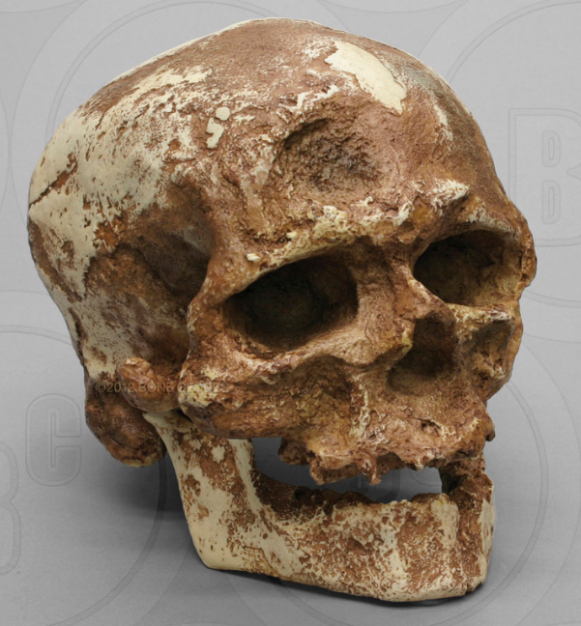

skeleton). 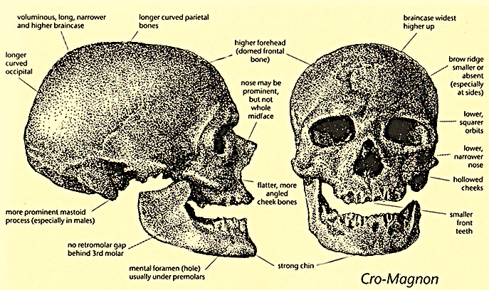

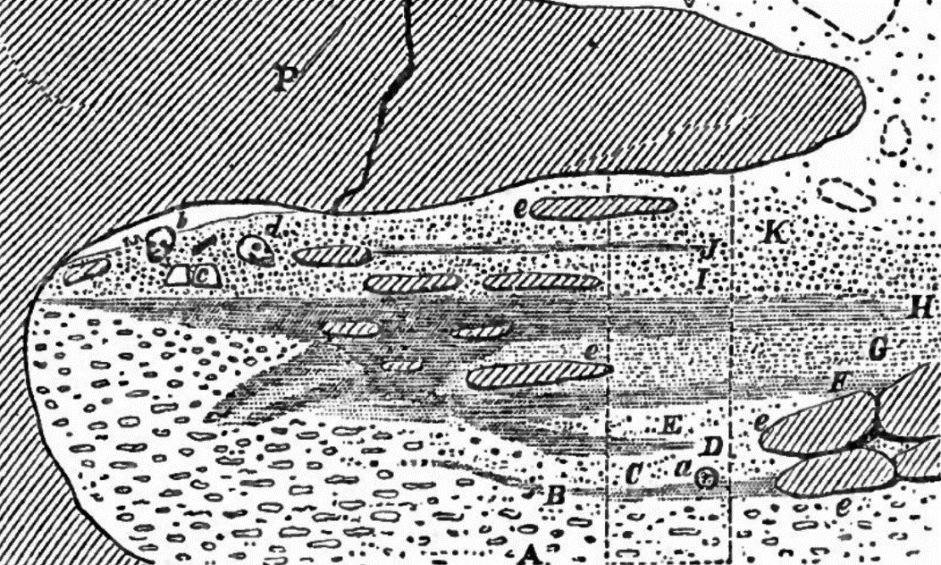Fig. 1. Cro-Magnon 1 cranium (with technical anatomical details) as excavated in 1868 by L. Lartet in the "Creux" (or “hollow,” or “rock shelter” phonetically spelled “Cro”) "Magnon" (the name of the landowner) hence, “Cro-Magnon”. From <https://userscontent2.emaze.com/images/3a16697d-e661-41dd-b0d9-e7a0c85f7af3/f9a831cc-0630-4727-a378-cae5828d7eeb.jpg>.

Fig. 2. This is a section through the Rock-shelter where b and d are the Cro-Magnon remains in K, the “calcareous debris,” *above* H, the last occupation stratum. Munro (1912) after Lartet (1868:141, fig. 6).

A Debris of the soft limestone.  
B First layer of ashes, etc.   
C Calcareous debris.   
D Second layer of ashes, etc.   
E Calcareous debris reddened by lire.   
F Third layer of ashes, etc.   
G Bed earth, with bones, etc.   
H Thickest layer of ashes, bones, etc.   
I Yellowish earth, with bones, flints, etc.   
J Thin bed of earth-stuff.   
K Calcareous debris.

L Rubbish of the talus.   
N Crack in the projecting ledge of rock.   
P Projecting shelf of hard lime-stone.   
Y Place of the pillar to support the roof.  
a Tusk of an elephant.   
b Bones of an old man.   
c Block of gneiss.   
d Human bones.   
e Slabs of stone fallen from the roof at different times

**Formal Label: *Homo sapiens sapiens*, “Cro-Magnon Man”.**

**Display Description:**

This Cro-Magnon skull was discovered by L. Lartet and H. Christy on a cliff in 1868 (during the construction of railway lines in Les-Eyzies, France). Cro-Magnon, meaning "big cliff," represents the earliest modern humans from Western Europe. Classic modern human features include a large brain capacity (over 1600 cc), shortened face with rectangular eye sockets, a high forehead, hollowed cheekbones, and noticeable chin. Many feel Cro-Magnon is more similar in appearance to modern Africans than modern Europeans, suggesting that this population came from Africa or Asia. The Bone Clones® Hominid line is composed of discoveries from anatomically modern humans, archaic humans, early Homo, early hominins, and other hominids. The majority of the casts in this line have been recreated by our team of anatomical sculptors. Some are reconstructions made by anthropology professionals using fragmentary elements from original discoveries and extrapolating the missing parts from those (i.e. Neanderthal The skull of the male Cro-Magnon (b) has a cephalic index of 73.6 (*dolichocephalic)*, a brain case capacity of 1590 cc and a body height of 1.82 m (5.97 ft), all of which fall into the range of *Homo sapiens sapiens* (Delluc 2010; Groenen 1994).

How old are the Cro-Magnon fossils? Referring to Fig. 2,the Cro-Magnon remains (b and d) lay *within* K, the “calcareous debris,” along with slabs (e) that had fallen from the roof, *above and after* the culture stratum, H (“the thickest layer of ashes and bones”), had been deposited when the cave was last occupied. So, the Cro-Magnon fossils are younger than the original cave occupants who lived pre-28,000 BP. This is substantiated by radio-carbon dating. A *Littorina* shell, which was associated with the Cro Magnon skulls (b, male, and d, female) produced an AMS C14 date of 27,680±270 BP (Beta -157439), which proves that that the Cro-Magnon skulls date to the early Gravettian (or post 28,000 BP) and do not date to the Magdalenian (before 28,000 BP) as was once maintained by Professor Lartet (Delluc 2010).

**Accession Number:**

**LC Classification:** GN286.3.

**Date or Time Horizon:** 27,680±270 BP

**Geographical Area:** Les Eyzies de Tayac village in sw France.

**Map, GPS coordinates: 44.9401368, 1.0100555**

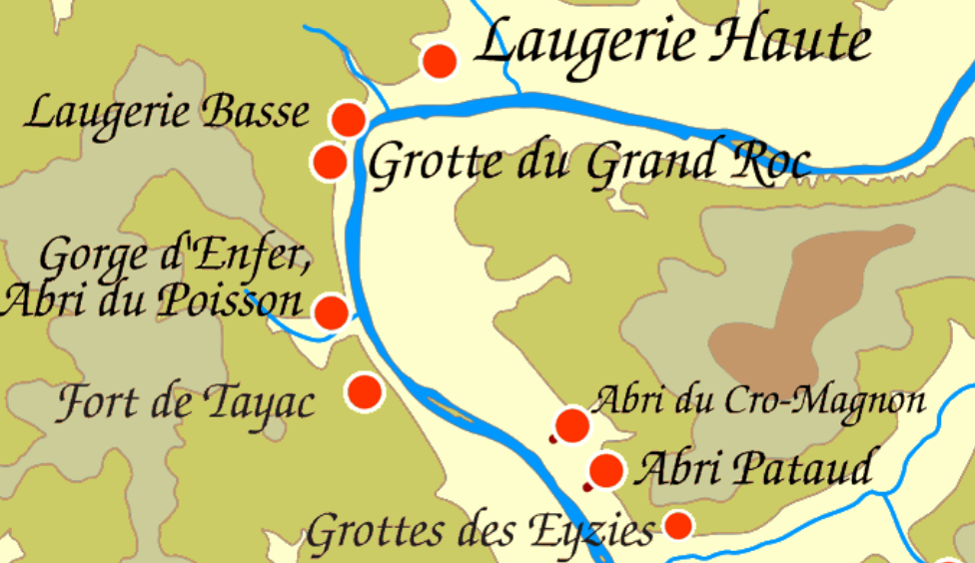 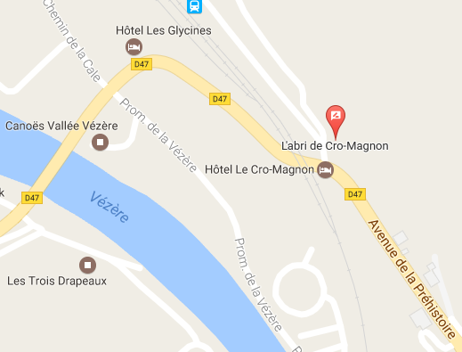

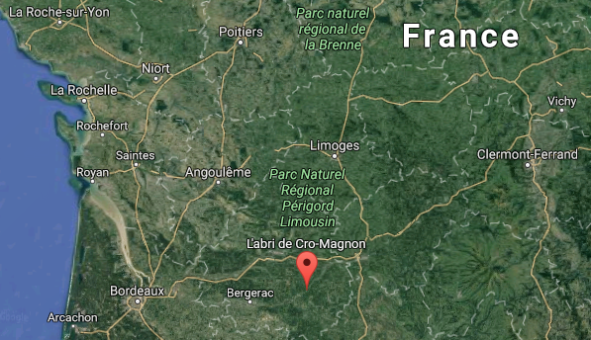

Figs. 3. Map of the location of L’Abri du Cro-Magnon (rock shelter), from <http://donsmaps.com/images31/vezereill2014.10.04.gif>.

Fig. 4. Detail of L’Abri du Cro-Magnon from https://www.google.com/maps.

Fig. 5. Location of L‘abri du Cro-Magnon in sw France from https://www.google.com/maps.

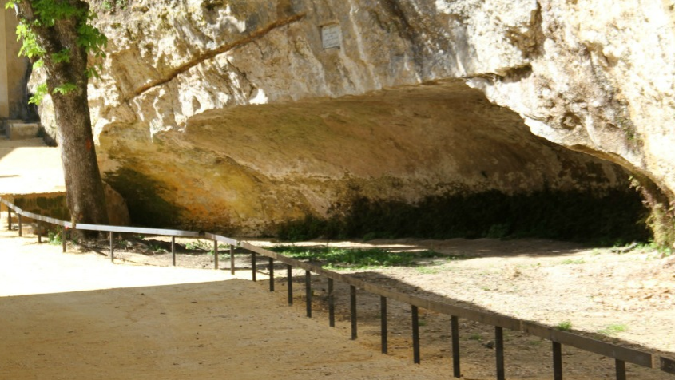

Fig. 5. Photo of L’Abri du Cro-Magnon (Rock Shelter) from [www.google.com/maps](http://www.google.com/maps).

**Cultural Affiliation:** *Homo sapiens sapiens.*

**Medium:** museum replica in resin.

**Dimensions:**

**Weight:**

**Condition:** museum replica in resin.

**Provenance:** Musée de l’Homme, Paris, display.

**Discussion:**

There are three hypotheses regarding how modern humans originated from Cro-Magnons (Homo sapiens sapiens).

The replacement model suggests that the Neanderthals living in Europe and Asia were replaced by early *Homo sapiens sapiens*, i.e. Cro-Magnons, who migrated out of Africa.

The regional continuity model suggests *Homo sapiens sapiens* evolved throughout Europe and Asia from *Homo erectus*, who originated in east Africa 1.8 Ma.

The assimilation model suggests *Home sapiens sapiens* migrated out of Africa and then interbred with preexisting European Neanderthals.

**References:**

Delluc, G. 2010. “Histoires d'Os au Paléolithique, Adamap XIIIe Conférence, *Paleos*

Groenen M. 1994. *Pour une Histoire de la Préhistoire*. Paris: Éditions Jérôme Millon.

Lartet, L. 1868. “Mémoire sur une sépulture des anciens troglodytes de Périgord, Annales des sciences naturelles II ,” *Zoologie*, 5ème Série, X.

Munro, Robert. 1912. *Palæolithic man and terramara settlements in Europe: being the Munro lectures in anthropology and prehistoric archæology in connection with the University of Edinburgh, delivered during February and March 1912.* Edinburgh: Oliver & Boyd.